1. Team Membership

Team Name: Cold Fries

Course: EE585

Date: 1/30/2022

| Name (Last, First) | Major(EE, CE, CS) |
| --- | --- |
| Do, Kenny, P969V743 | CE |
| Perez, Kevin, A453B383 | EE |
| Vu, Khai, U326Q228 | CS |
| Nguyen, Michael, P955Z557 | CS |
| Sonexarth, Davin, S555D296 | CS |

1. Team Roles

Include a short description of the role(s) for each team member. Consider the experiences each member brings to the team that will support the project research/design/build phases.

Kenny Do - Circuitry / Team Lead / Co-Project Manager, Will mainly be involved with the design and creation of the project circuitry. In addition to that, will be leading the team in the aspect of meetings, deadlines, task delegation, and making sure all members are fine.  
  
Kevin Perez - Circuitry / Project Manager / Co-Team Lead, Will mainly be involved with the design and creation of the project circuitry. In addition to that, will be co-leading the team in the task delegation, meetings and checking up on other members  
  
Khai Vu - Programmer / Time Keeper, Will mainly be involved with the design and creation of the programming of the project. In addition to that, will be in charge of tracking the minutes, when every topic was talked at a certain time, and when time will be stopped if on a time crunch

Michael Nguyen - Programmer / Scribe, Will mainly be involved with the design and creation of programming of the project. In addition to that, will be in charge of writing down the topics during meetings, presenting new ideas to the group, and tracking down all important notes whenever presented.

Davin Sonexarth - Programmer / Facilitator / Online Media Organizer, Will mainly be involved with the design and creation of programming of the project. In addition to that, will be in charge of making sure all important and necessary items are present during meetings, setting up and organizing shared resources and storage, simplifying the placement of all online media sources such as proper placement of sources, etc.

Signatures

Each member needs to sign and date the Code of Conduct



Print: _________________________ Print: __________________________



Sign: _________________________ Sign: ___________________________

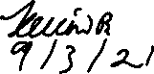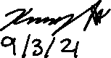

Date: _________________________ Date: __________________________



Print: __________Khai Vu_________ Print: __________________________   
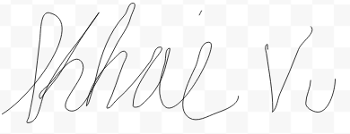



Sign: _________________________ Sign: ___________________________

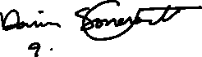

Date: _____9/5/21_______________ Date: __________________________





Print: _________________________ Print: __________________________

Sign: _________________________ Sign: ___________________________

Date: _________________________ Date: __________________________

